Name: dhruv kathiriya
Id:26it029
SET 1

Part A:-

Task 1:- Add metadata: character encoding, viewport, page title, description, author and a favicon
<head>
<!-- Character Encoding -->
<meta charset="UTF-8">

<!-- Viewport for Responsive Design -->
<meta name="viewport" content="width=device-width, initial-scale=1.0">

<!-- Description -->
<meta name="description" content="BrewNest Cafe near CHARUSAT campus - Fresh coffee, snacks & table reservation.">

<!-- Author -->
<meta name="author" content="Student Name">

<!-- Favicon Link -->
<link rel="icon" type="image/x-icon" href="favicon.ico">

<!-- Page Title -->
<title>BrewNest Cafe | Premium Experience</title>

<!-- External CSS -->
<link rel="stylesheet" href="style.css">
</head>

Task 2:- Create a <header> with a logo image and café name, and a <nav> containing an unordered list of
links to the About, Menu, Specials and Contact sections.
<header class="main-header">
<div class="logo">
<img src="logo.png" alt="BrewNest Cafe Logo">
<h2>BrewNest Café</h2>
</div>
<nav class="nav-bar">
<ul class="nav-links">
<li><a href="#about">About</a></li>
<li><a href="#menu">Menu</a></li>
<li><a href="#specials">Specials</a></li>
<li><a href="#contact">Contact</a></li>
</ul>
</nav>
</header>

Task 3:
About – a heading, two short paragraphs and one image with alt text.
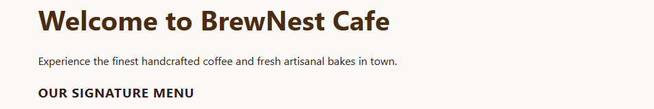

Menu – three <article> cards (Hot Coffee, Cold Brews, Snacks), each with a heading and a list
of 3 items with prices.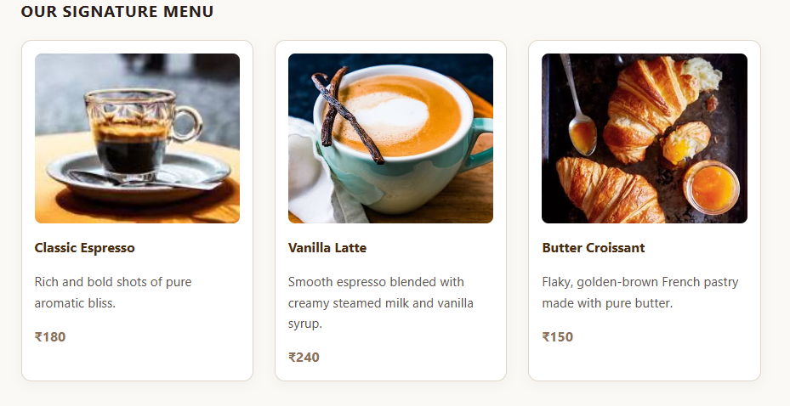
Price Table – a <table> with <thead> and <tbody> showing Item, Size and Price for at least 4
items.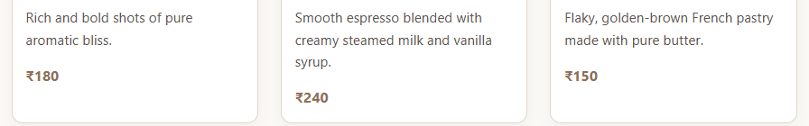

Contact – the café address inside <address> and a table-booking <form> with Name, Mobile
Number, Date, Number of Guests and a Submit button (use suitable input types and <label>
for every field).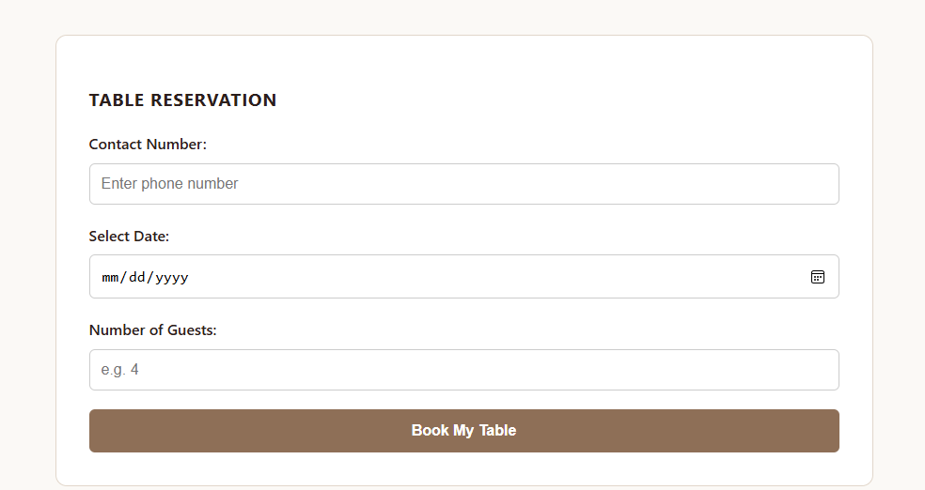

task 4:- Add an <aside> showing opening hours and one “Student Offer”.
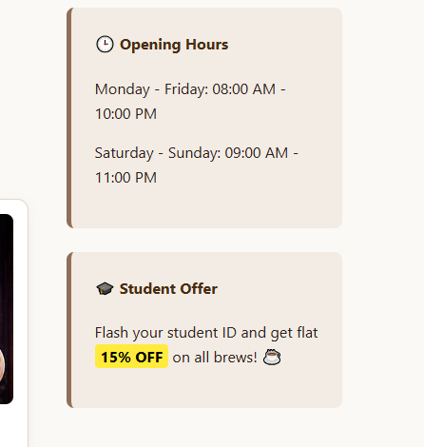

Task 5:- Add a <footer> with a copyright line and two social-media links.
<!-- Footer -->
<footer class="main-footer">
<p>&copy; 2026 BrewNest Cafe. All rights reserved.</p>
<div class="social-links">
<a href="#" target="_blank">Instagram</a>
<a href="#" target="_blank">Facebook</a>
</div>
</footer>

Part B:-
1:-
Set font-family and text color only once on body , so all elements inherit them.
body {
font-family: 'Segoe UI', Tahoma, Geneva, Verdana, sans-serif;
color: #2b1f1d;
background-color: #fbf9f6;
margin: 0;
padding: 0;
line-height: 1.6;
}

2:-
h3 {
text-transform: uppercase;
letter-spacing: 1px;
}

/* Class Selector */
.section-title {
border-bottom: 2px solid #8e6f57;
padding-bottom: 10px;
}

/* ID Selector */
#special-heading {
font-size: 2.5rem;
margin-bottom: 10px;
}

/* Descendant Selector (Requirement 2) */
/* Targetting only specific 'strong' element inside '.offer-box' container */
.offer-box strong {
background-color: #ffeb3b;
padding: 2px 6px;
border-radius: 4px;
color: #000000;
}

3:-

.menu-grid {
display: grid;
grid-template-columns: repeat(3, 1fr);
gap: 25px;
margin-top: 20px;
}

4:-
.highlight-text {
color: #8e6f57; /* Light Taupe Brown */
}

#special-heading {
color: #4a2c11; /* Espresso Dark Brown */
}

5:-
.main-header {
display: flex;
justify-content: space-between;
align-items: center;
background-color: #4a2c11;
padding: 15px 5%;
color: #ffffff;
box-shadow: 0 4px 12px rgba(0, 0, 0, 0.08);
}

.main-header .logo h2 {
margin: 0;
}

.nav-links {
display: flex; /* Nav links aligned horizontally in a row */
list-style: none;
margin: 0;
padding: 0;
gap: 30px;
}

.nav-links a {
color: #f5efe6;
text-decoration: none;
font-weight: 500;
transition: color 0.3s ease;
}

.nav-links a:hover {
color: #ffffff;
}

6TH:-
.menu-grid {
display: grid;
grid-template-columns: repeat(3, 1fr);
gap: 25px;
margin-top: 20px;
}

7TH:-
.menu-card img {
width: 100%;
height: 200px;
object-fit: cover;
border-radius: 8px;
display: block;
max-width: 100%; /* Strict check against image overflow */
}

@media (max-width: 992px) {
.menu-grid {
grid-template-columns: repeat(2, 1fr);
}
}

/* Requirement 7b: At 600px or less it shows 1 column, nav links stack vertically, and <aside> moves below */
@media (max-width: 600px) {
/* 1 column grid layout */
.menu-grid {
grid-template-columns: 1fr;
}

/* Header dynamic flex tracking to wrap elements vertically */
.main-header {
flex-direction: column;
gap: 20px;
}

/* Nav links align inside a vertical stack column */
.nav-links {
flex-direction: column;
gap: 15px;
text-align: center;
}

/* Flex wrapper configuration to push the <aside> layer below the primary main layout block */
.container {
flex-direction: column;
}
}
8TH:-

